SCHOOL OF COMPUTER SCIENCE AND ARTIFICIAL INTELLIGENCE |  |  |  |  | DEPARTMENT OF COMPUTER SCIENCE ENGINEERING
Program Name:B. Tech |  |  |  | Assignment Type: Lab |  |  | Academic Year:2025-2026
Course Coordinator Name |  |  |  | Dr. Rishabh Mittal
Instructor(s)Name |  |  |  | Mr. S Naresh Kumar  Ms. B. Swathi  Dr. Sasanko Shekhar Gantayat  Mr. Md Sallauddin  Dr. Mathivanan  Mr. Y Srikanth  Ms. N Shilpa  Dr. Rishabh Mittal (Coordinator)  Dr. R. Prashant Kumar  Mr. Ankushavali MD  Mr. B Viswanath  Ms. Sujitha Reddy  Ms. A. Anitha  Ms. M.Madhuri  Ms. Katherashala Swetha  Ms. Velpula sumalatha  Mr. Bingi Raju  Mr. G. Kranthi
Course Code |  |  | 23CS002PC304 | Course Title |  | AI Assisted Coding
Year/Sem |  |  | III/I | Regulation |  | R23
Date and Day  of Assignment |  |  | Week 7 - Thursday | Time(s) |  | 23CSBTB01 To 23CSBTB52
Duration |  |  | 2 Hours | Applicable to  Batches |  | All Batches
AssignmentNumber:14.4 (Present assignment number)/24(Total number of assignments)
 | Q.No. | Question |  |  |  |  |  | ExpectedTime  to complete
 | 1 | Lab 14: Web Frontend Development – AI-Assisted HTML/CSS/JS Generation  Lab Objectives  - Design functional, visually appealing web applications using HTML, CSS, and JavaScript with AI assistance.  - Apply responsive, accessible, and interactive design principles.  - Create practical UI components for real-world web applications.  - Use AI to optimize layout, UX, and performance.  Lab Outcomes  - Applying AI assistance to frontend development tasks  - Understanding how HTML, CSS, and JavaScript work together  - Improving responsiveness, interactivity, and usability  - Evaluating and refining AI-generated frontend code |  |  |  |  |  | Week 7

Task 1: Responsive Homepage Layout for a Startup Website

Scenario
You are designing a basic homepage for a startup company that needs to look good on desktops, tablets, and mobile devices.

Task Description
- Create a web page structure using HTML that includes:
  - A header with navigation links
  - A main content section
  - A footer with basic information
- Use AI assistance to generate responsive CSS using media queries.
- Ensure the layout adjusts smoothly across different screen sizes.

Expected Output
- A responsive web page where:
  - Header, content, and footer are clearly separated
  - Layout adapts correctly to mobile, tablet, and desktop views
  - Code is clean and well-structured
Prompt:-
Code:-
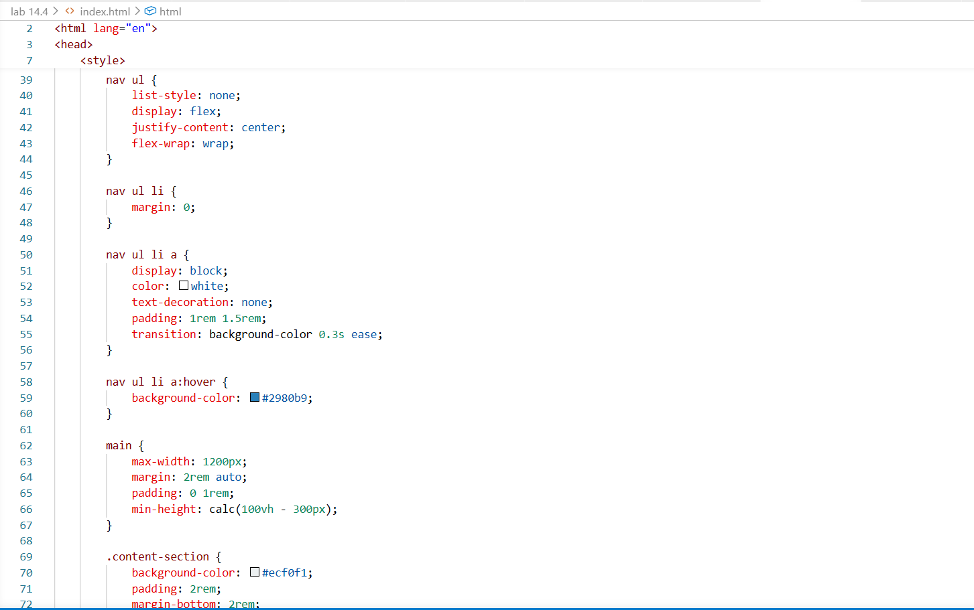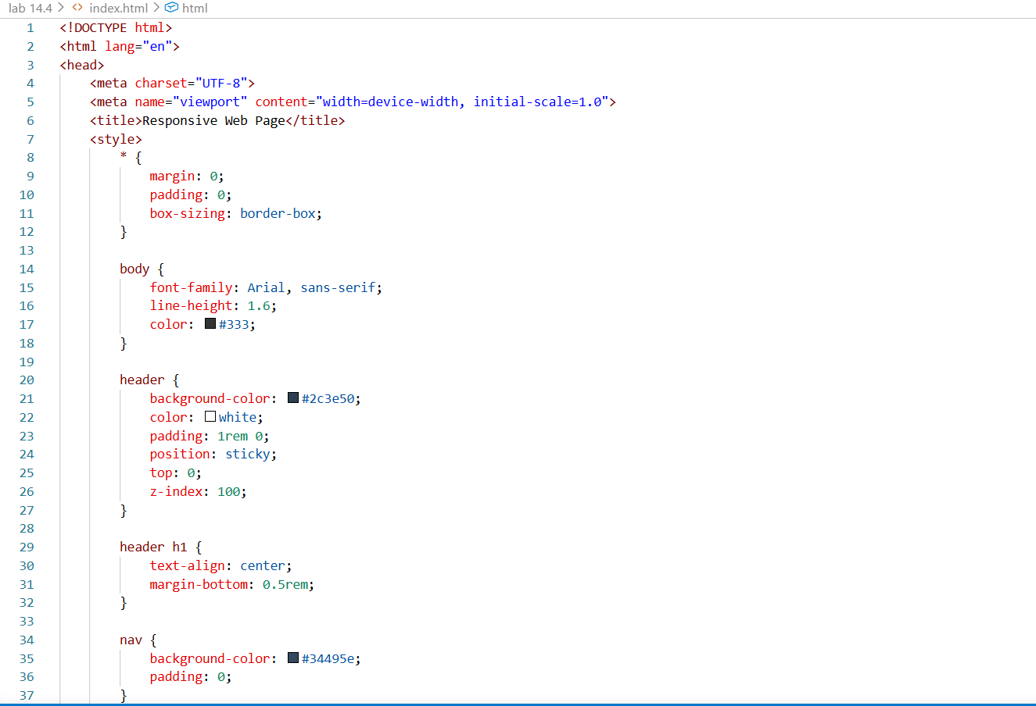
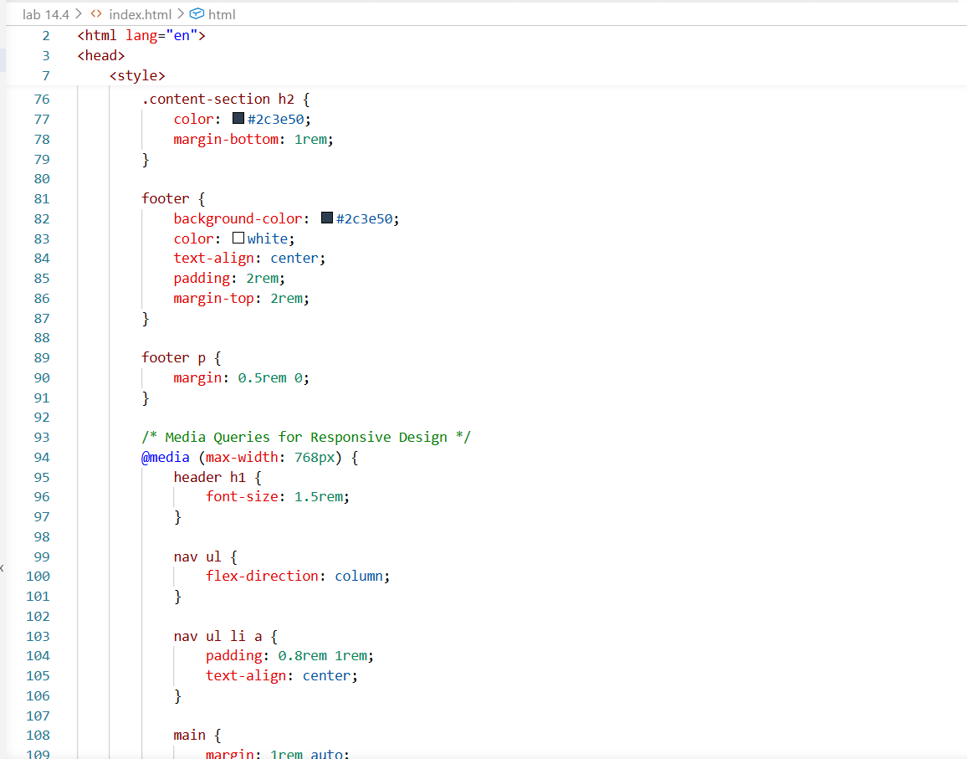
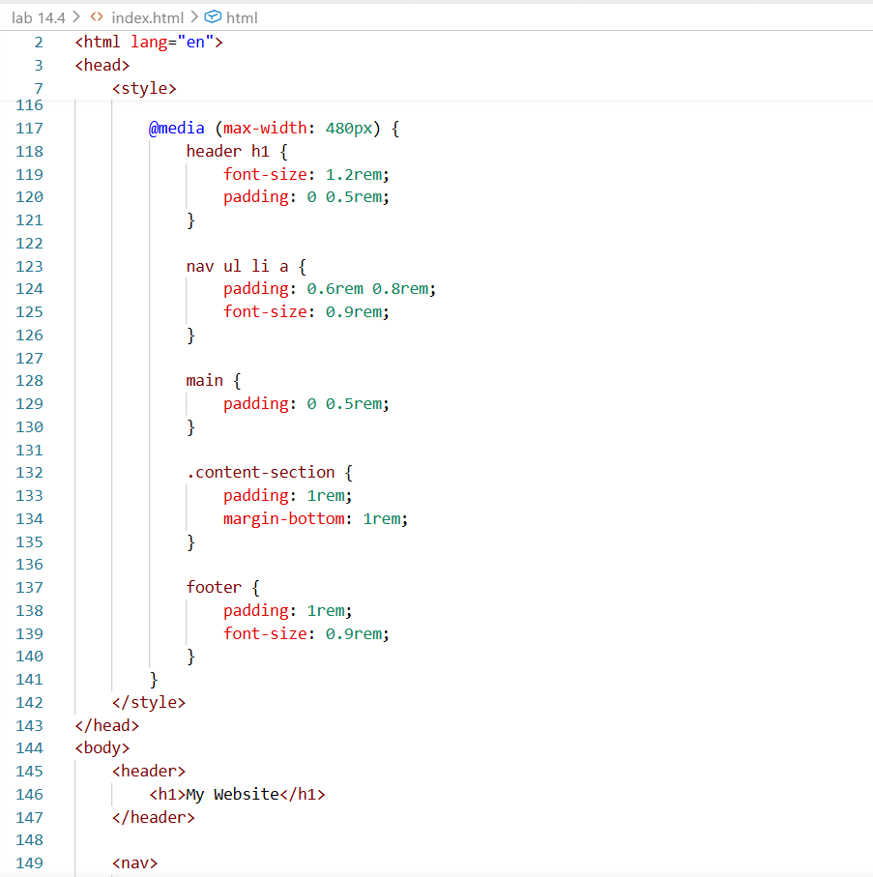
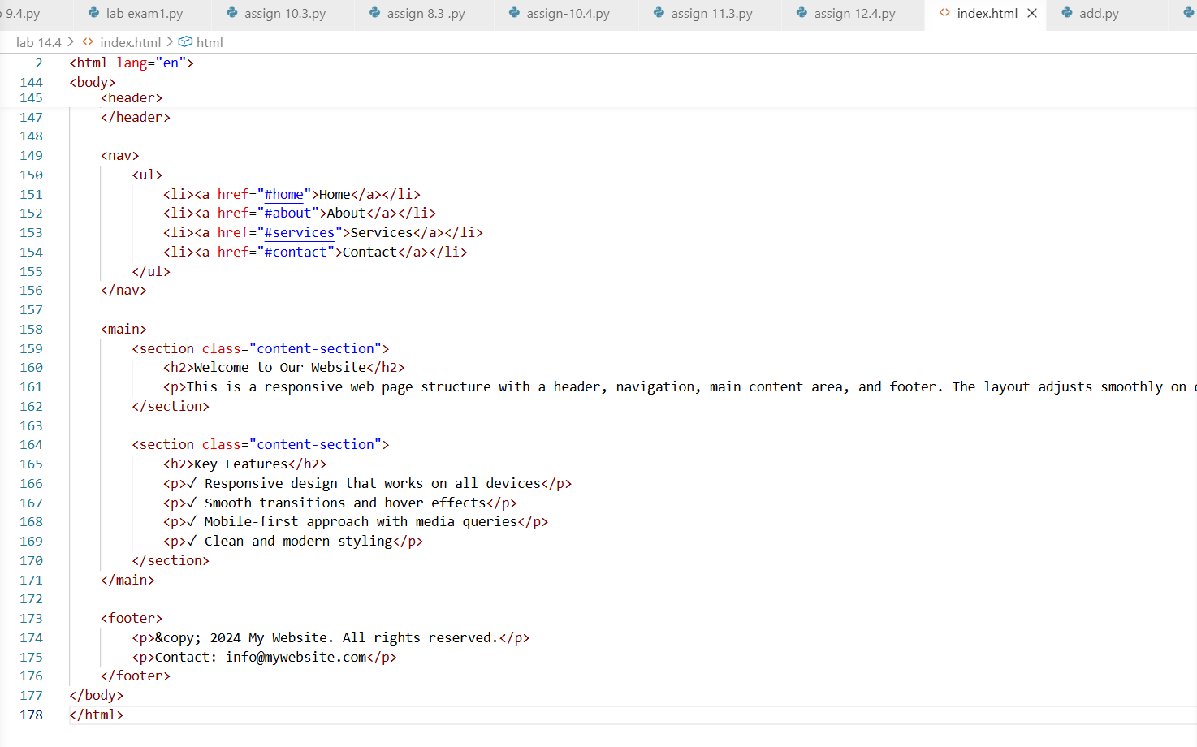

Output:-
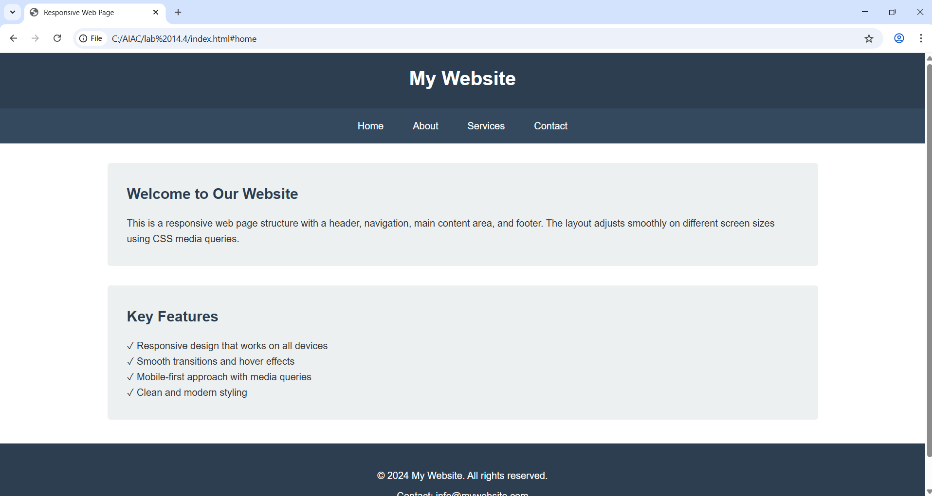
Explanation: -
This task creates a basic webpage layout with a header, main content section, and footer using HTML. Responsive CSS with media queries is used so the layout adjusts properly for desktop, tablet, and mobile screens. This ensures the website looks good on different devices.

Task 2: Interactive Call-to-Action Button

Scenario
A marketing page requires a call-to-action button that responds when users interact with it.

Task Description
- Add a button to a web page using HTML.
- Use AI to generate JavaScript that responds to the button click by:
  - Displaying a message or alert
- Ask AI to add meaningful comments explaining the JavaScript logic.

Expected Output
- A web page where:
  - Clicking the button triggers a visible response (alert or message)
  - JavaScript code is readable and commented
  - No page reload occurs
Prompt:-
Code:-
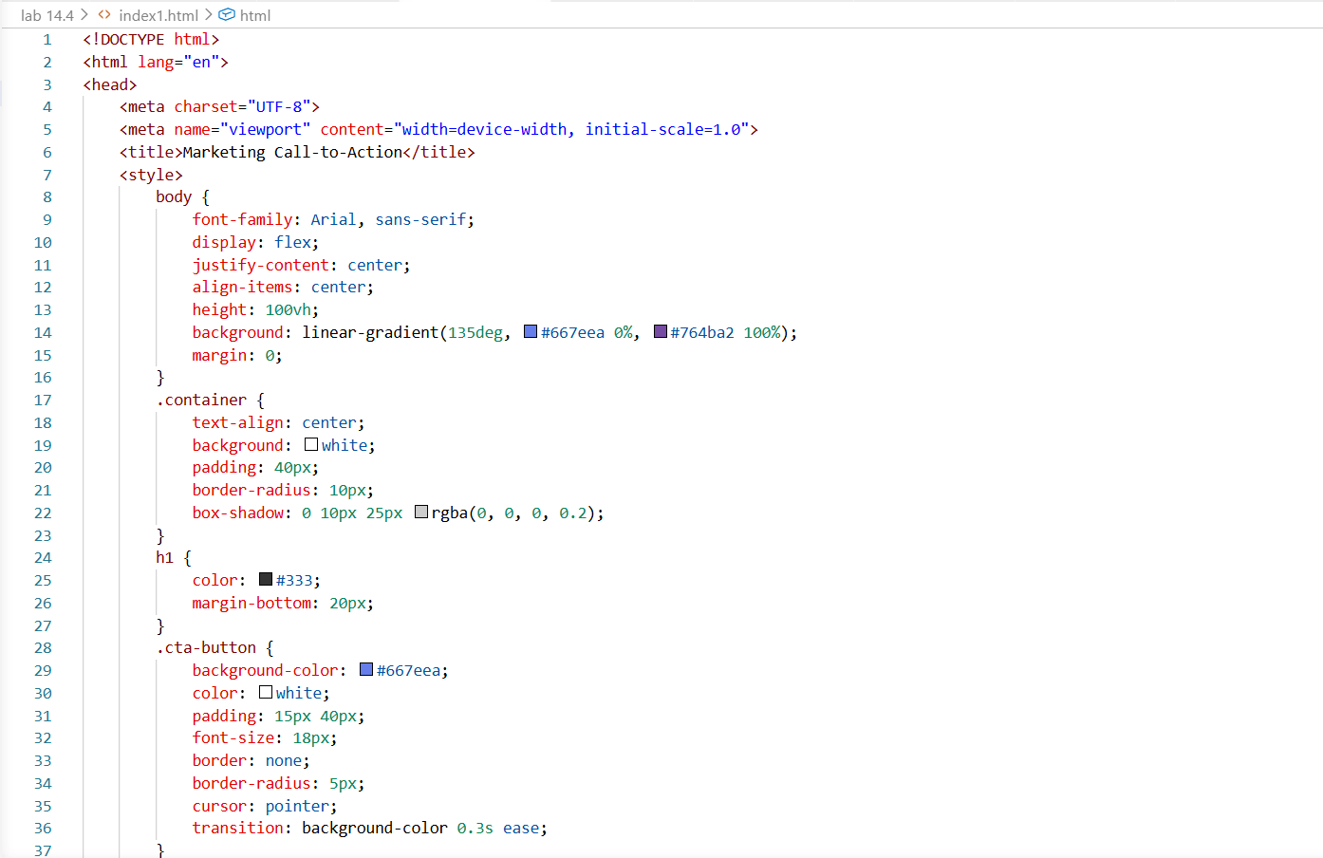
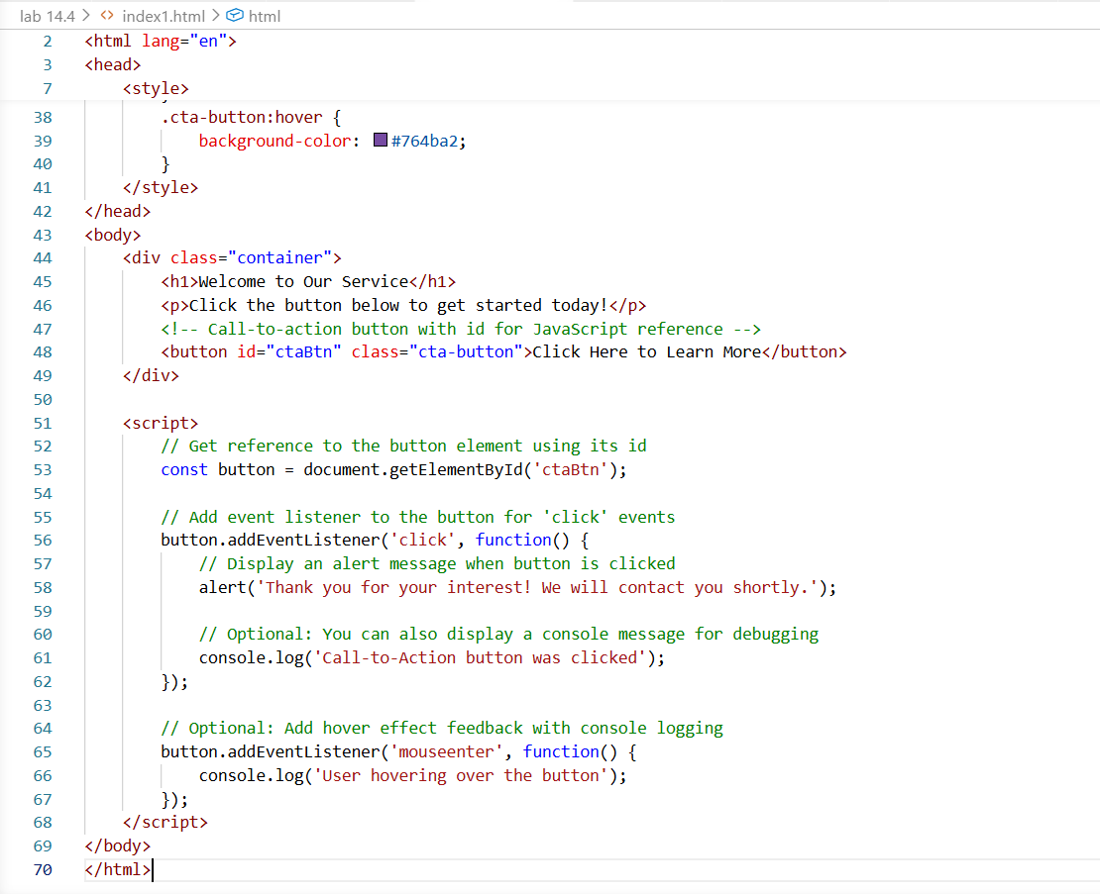

Output:-
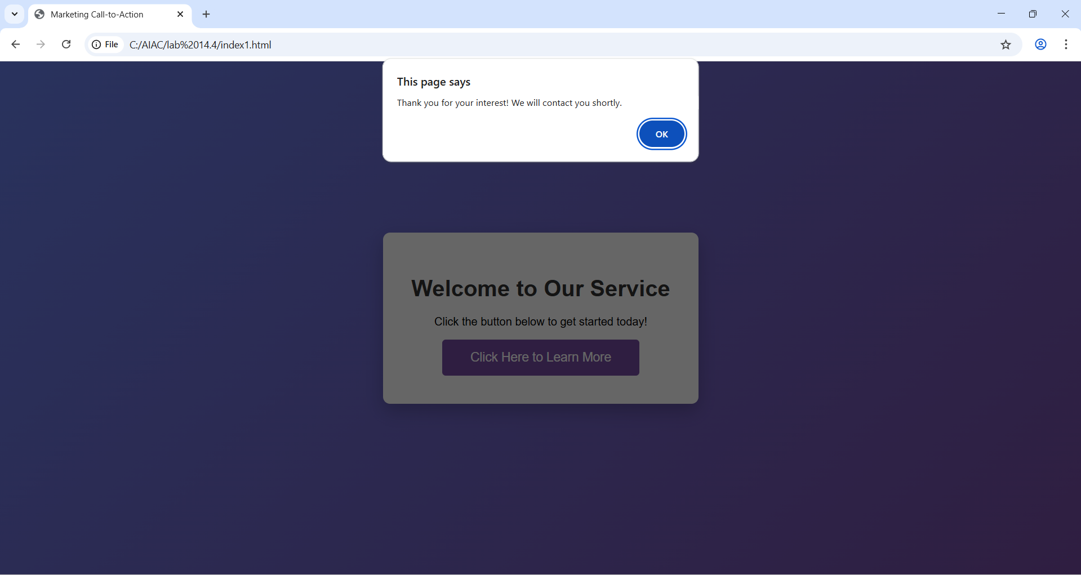
Explanation:-
A call-to-action button is added using HTML, and JavaScript is used to detect when the user clicks the button. When clicked, it displays an alert or message without reloading the page. This makes the webpage interactive and improves user engagement.

Task 3: Contact Form with Client-Side Validation

Scenario
You are developing a contact form for a company website to collect user queries safely and correctly.

Task Description
- Design a form with fields for:
  - Name
  - Email
  - Message
- Use AI to generate JavaScript validation logic that:
  - Prevents empty submissions
  - Checks for a valid email format
- Display clear error messages for invalid input.

Expected Output
- A functional form where:
  - Invalid input shows inline error messages
  - Valid input displays a success message
  - Validation happens on the client side using JavaScript
Prompt:-
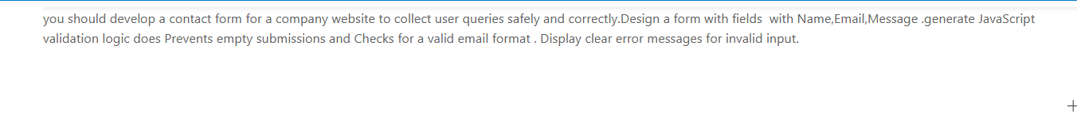
Code:-
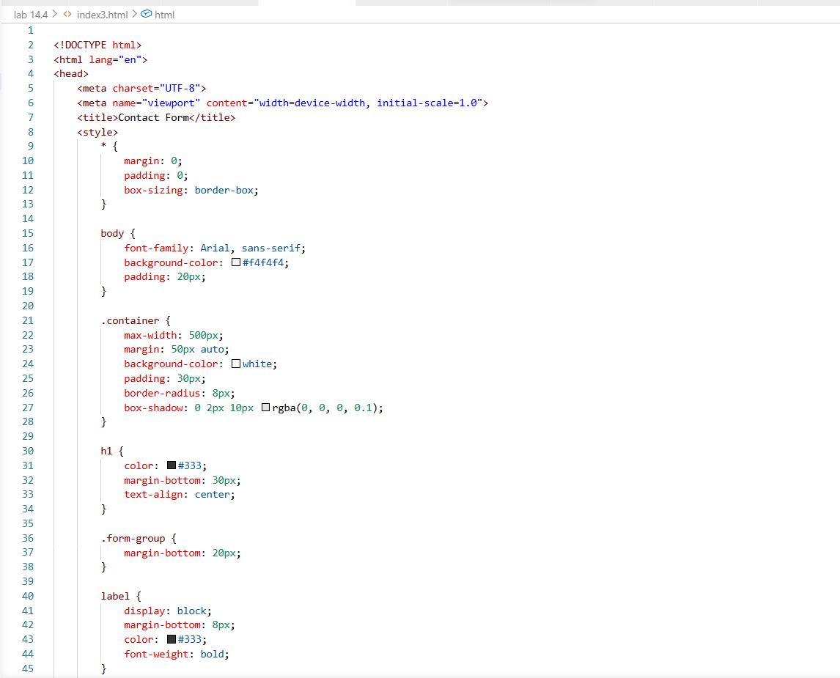
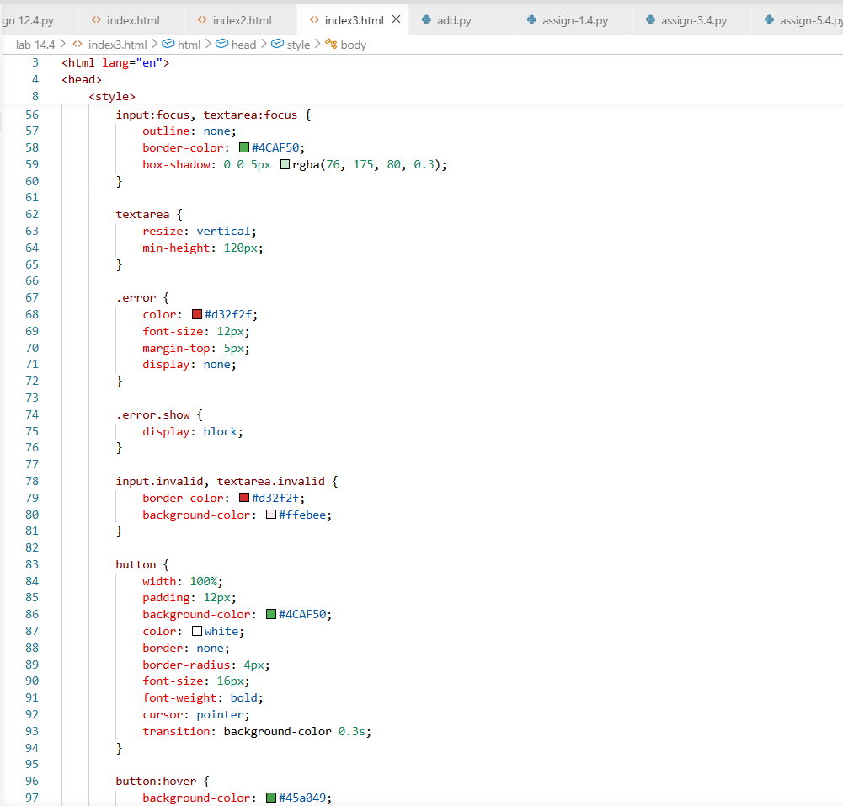

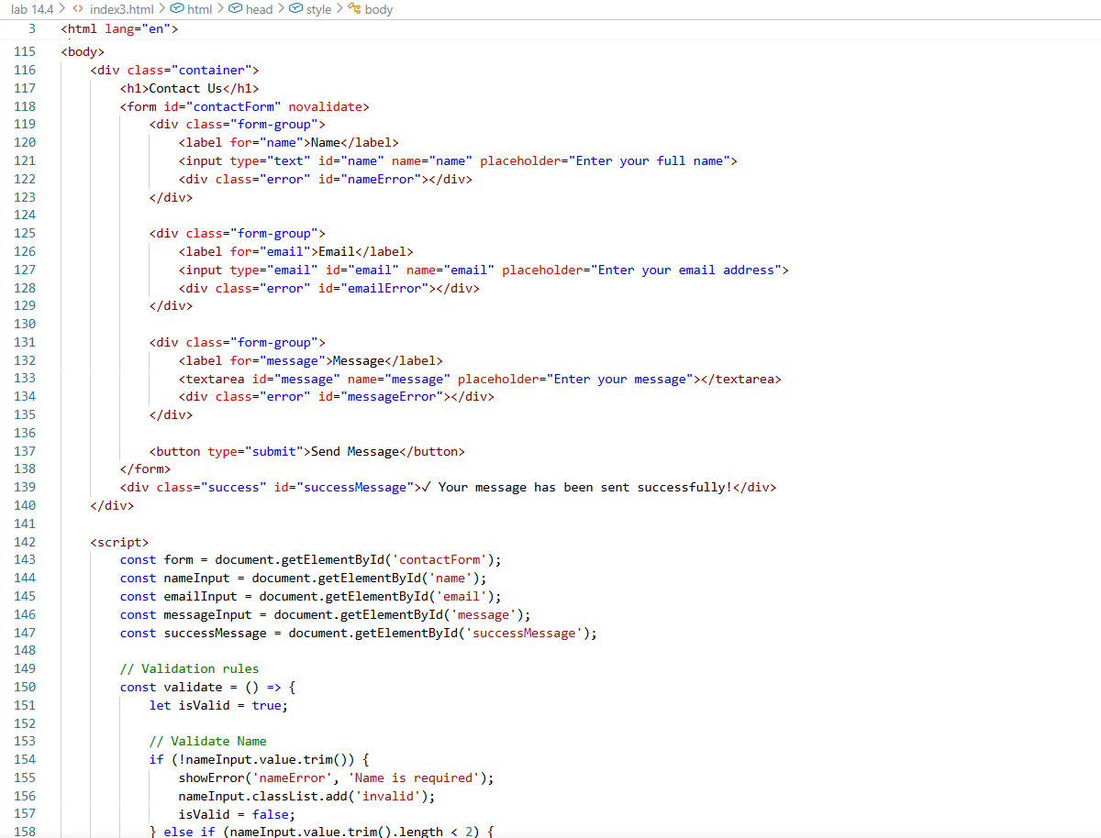
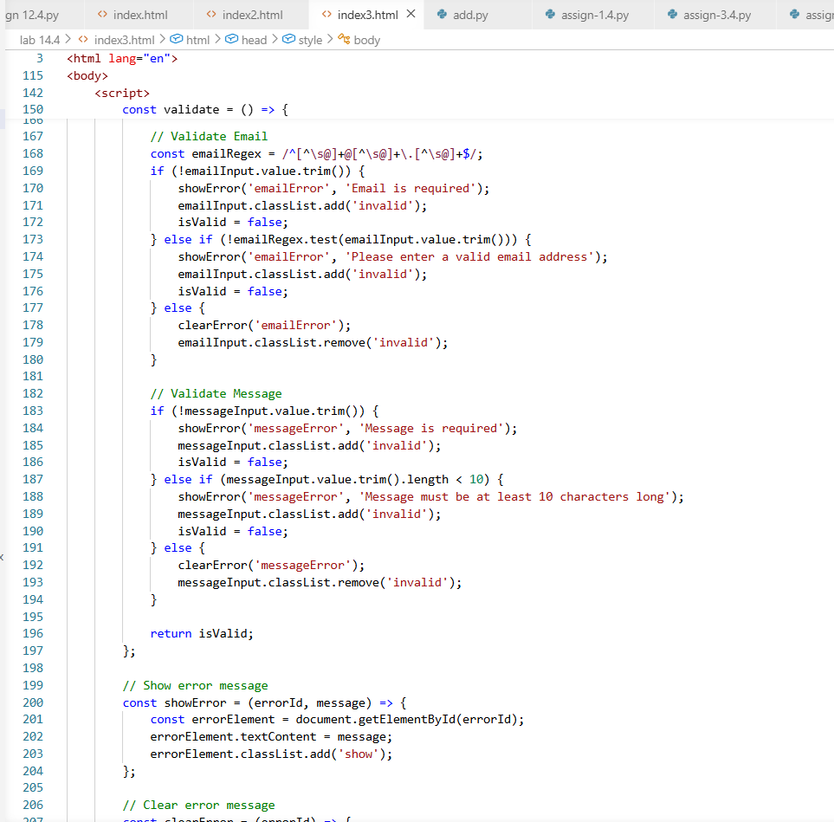
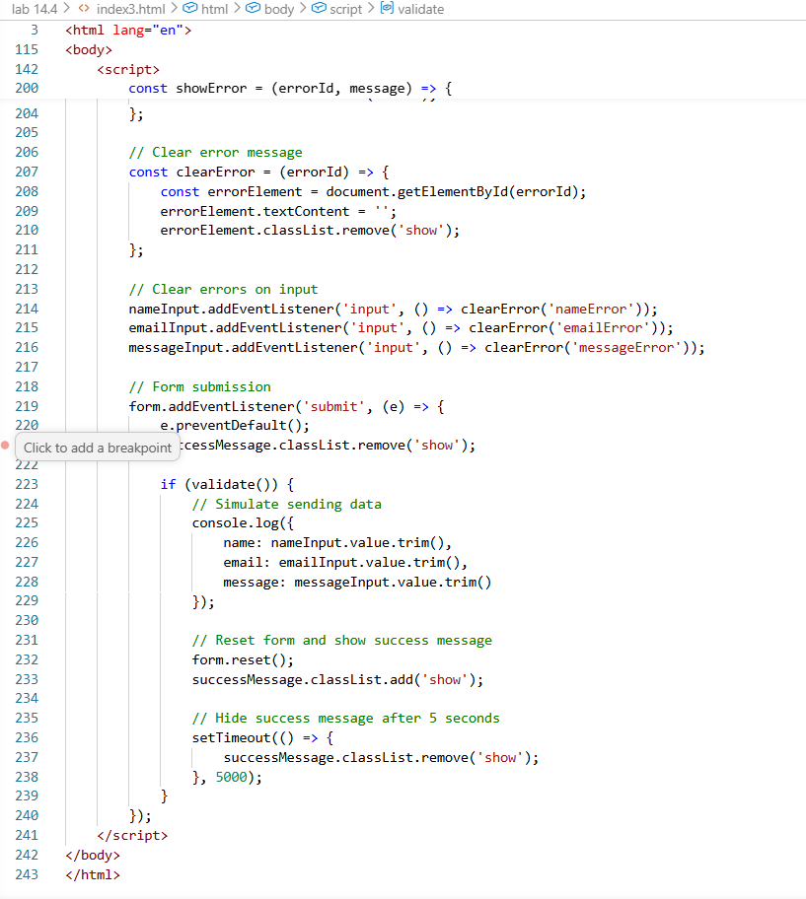
Output:-
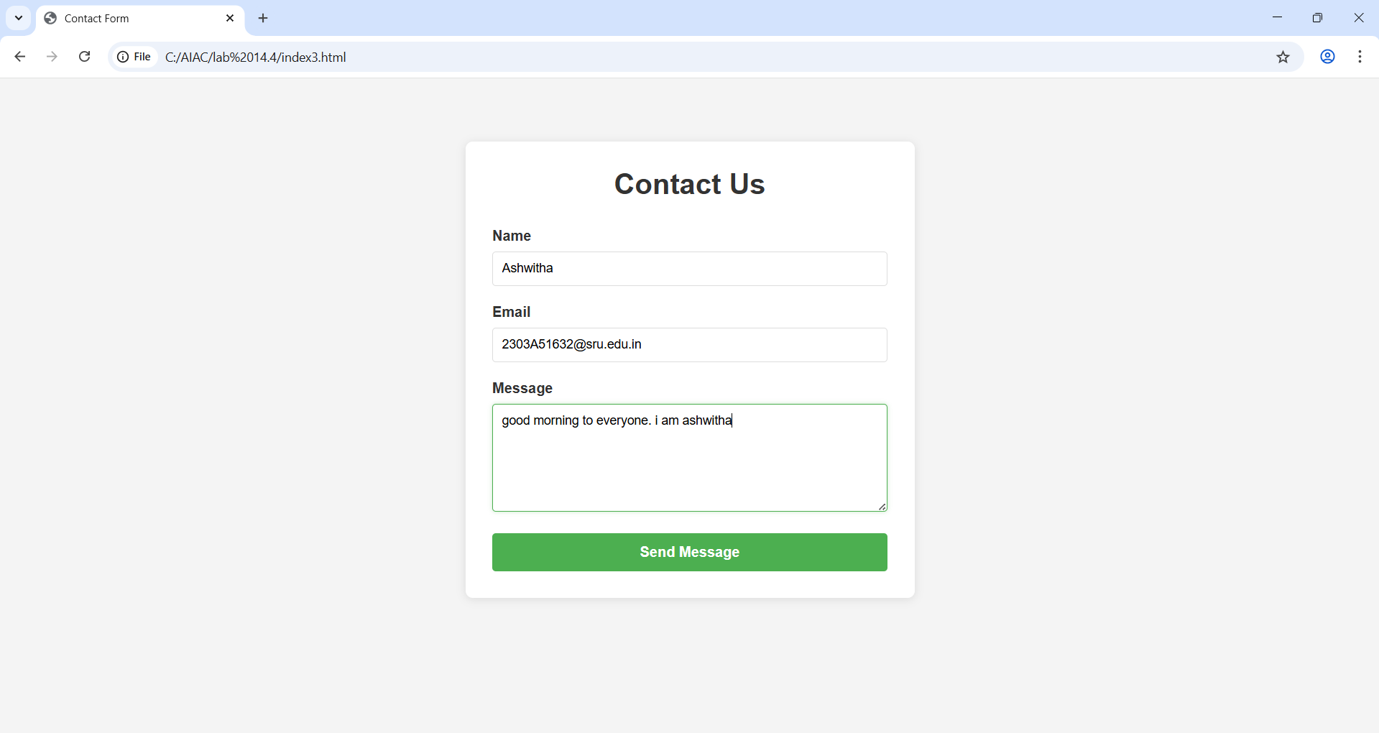

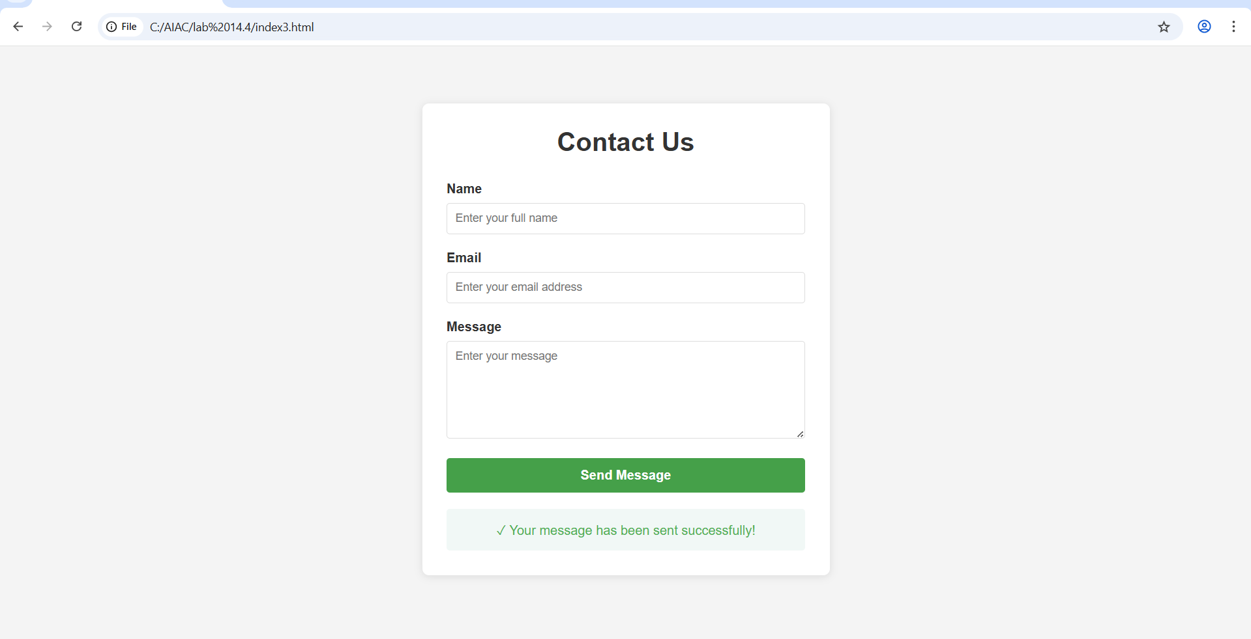
Explanation:-
A contact form is created with fields for name, email, and message. JavaScript validation checks that all fields are filled and the email format is correct before submission. Error messages are shown for invalid input, and a success message appears for valid entries.

Task 4: Dynamic List Management for a Product Page

Scenario
A product listing page needs to add or remove items dynamically without refreshing the page.

Task Description
- Create a simple HTML list to display items.
- Use AI to generate JavaScript that:
  - Adds a new item when an “Add” button is clicked
  - Removes the last item when a “Remove” button is clicked
- Ensure the DOM updates dynamically.

Expected Output
- A web page where:
  - Items can be added and removed dynamically
  - Changes appear instantly without page reload
  - JavaScript logic is clear and maintainable
Prompt:-
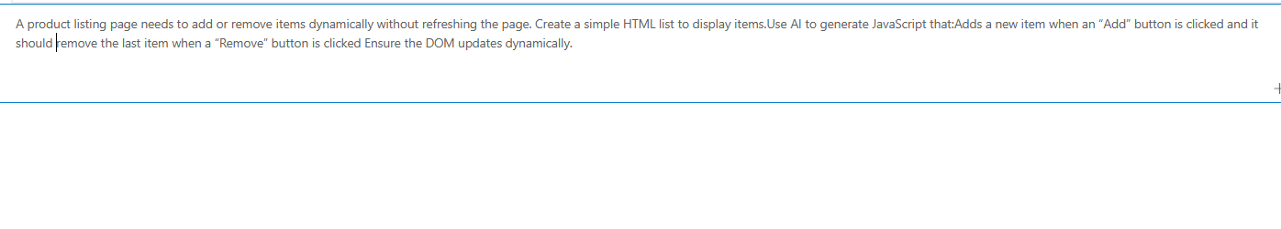
Code:-
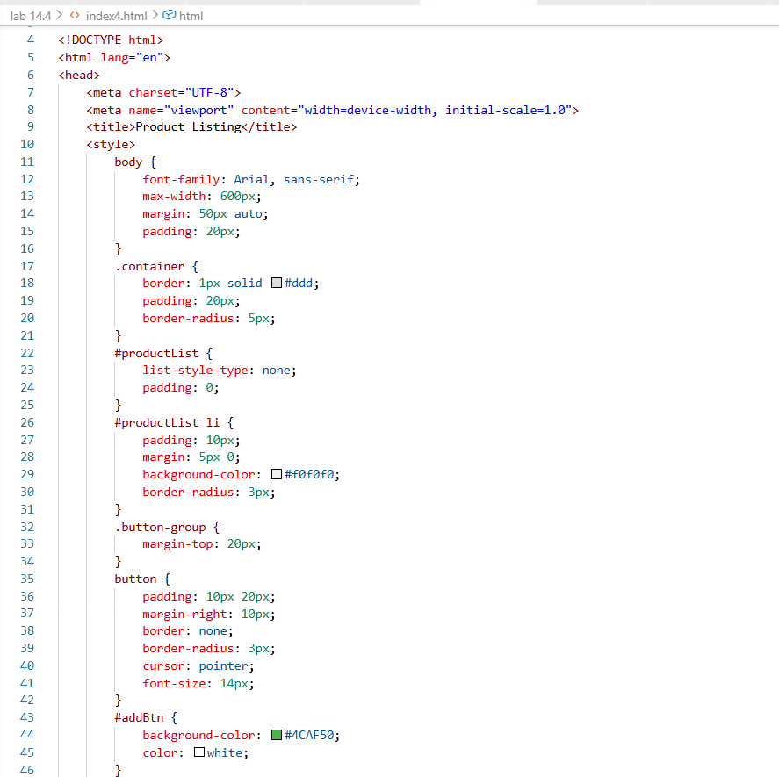
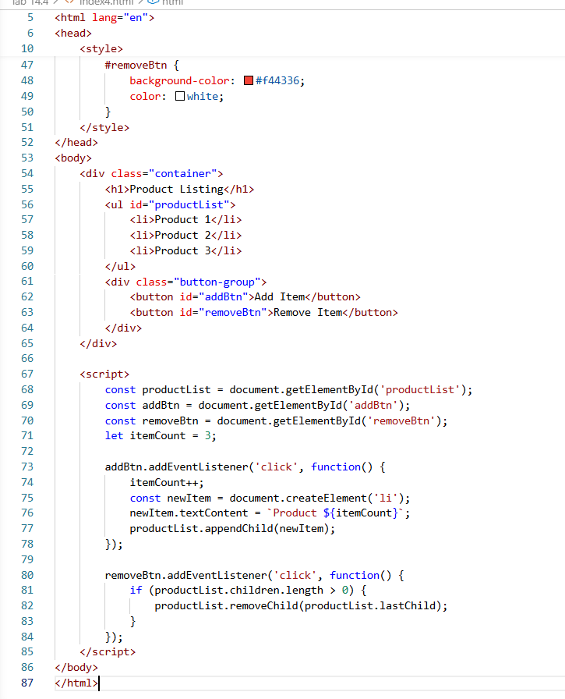

Output:-
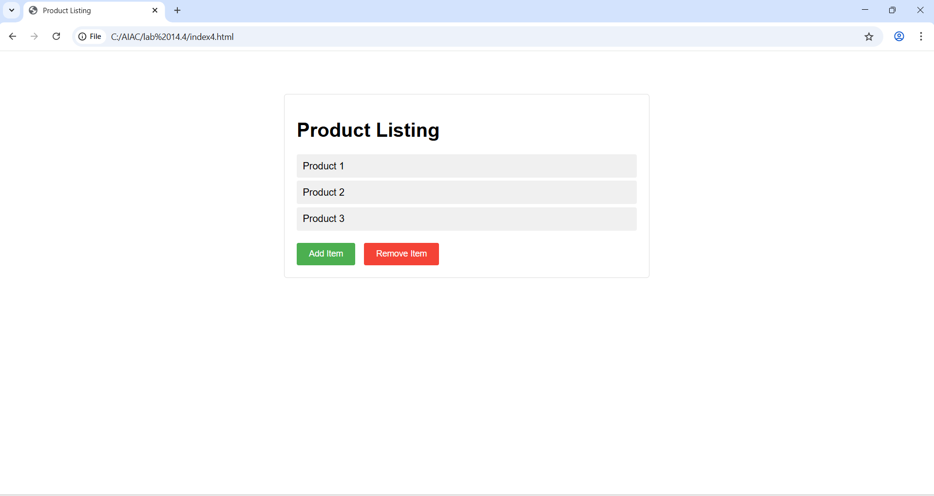

Add Item:-
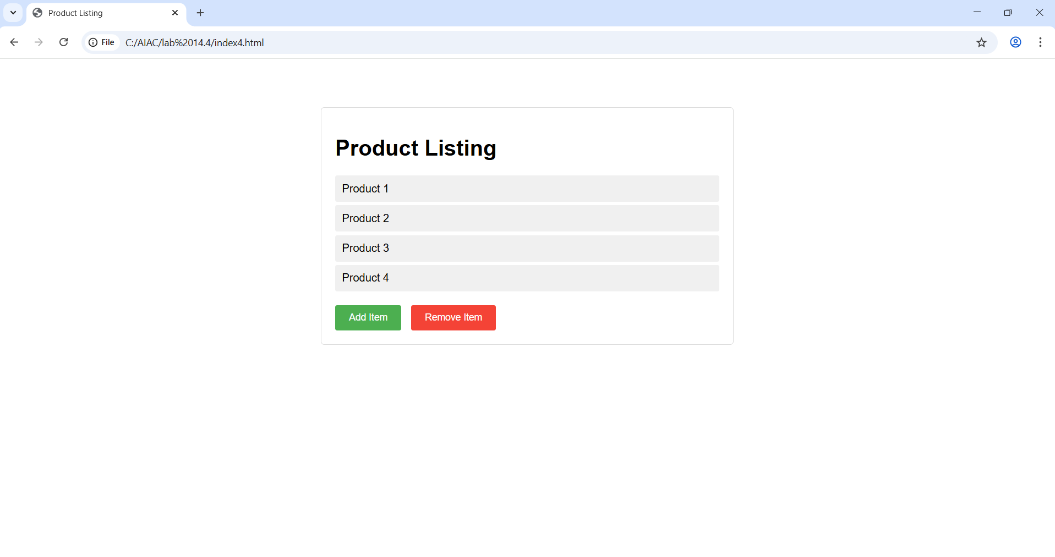

Remove item:-
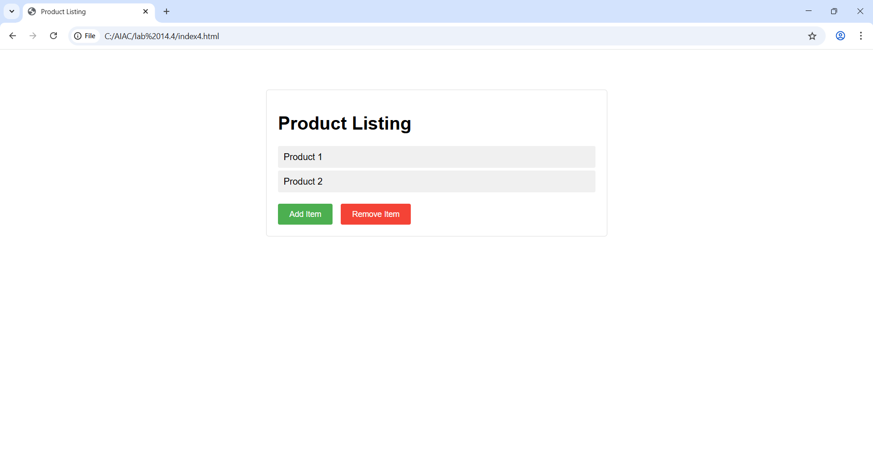
Explanation:-
An HTML list is used to display items, and JavaScript allows items to be added or removed dynamically. When the “Add” button is clicked, a new item is added to the list, and the “Remove” button deletes the last item. The page updates instantly without reloading.

Task 5: Modal Popup for User Notifications

Scenario
You are building a user notification popup for announcements or alerts on a website.

Task Description
- Use AI to help generate:
  - HTML structure for a modal popup
  - CSS styling with a semi-transparent background overlay
  - JavaScript to open and close the modal
- Include multiple ways to close the modal (button or overlay click).

Expected Output
- A web page where:
  - Clicking “Open Modal” displays the popup
  - Popup overlays the page content clearly
  - Modal closes smoothly when instructed
Prompt:-
Code:-
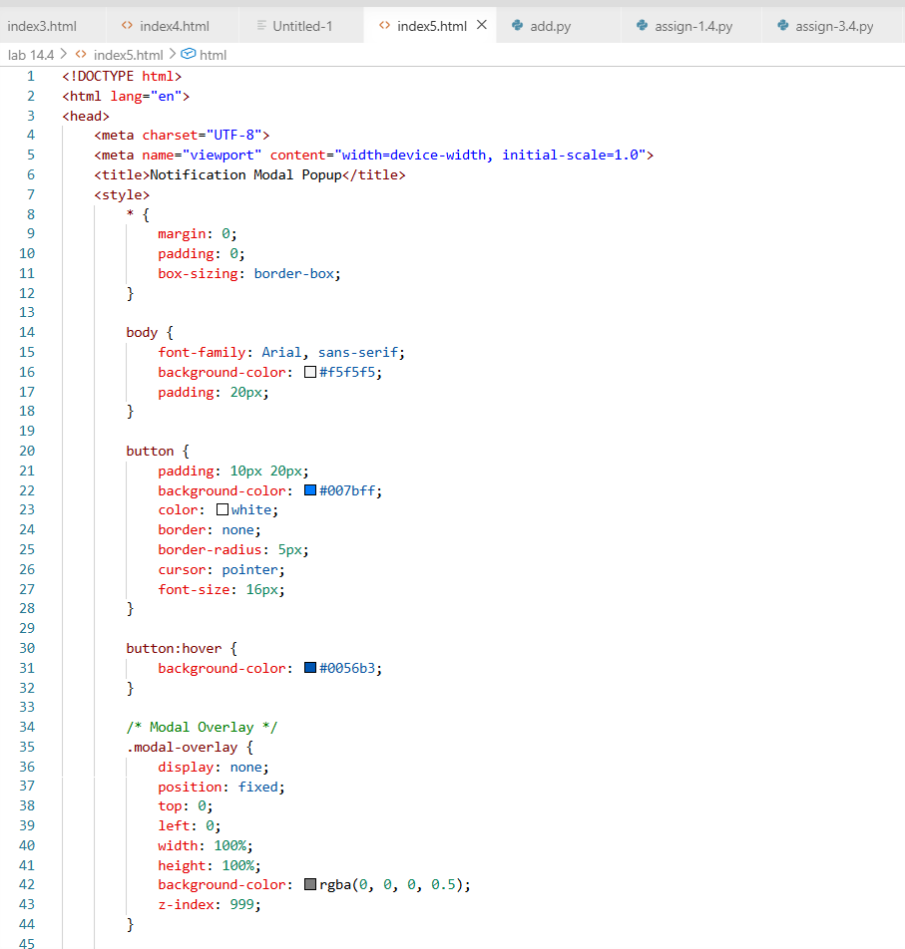
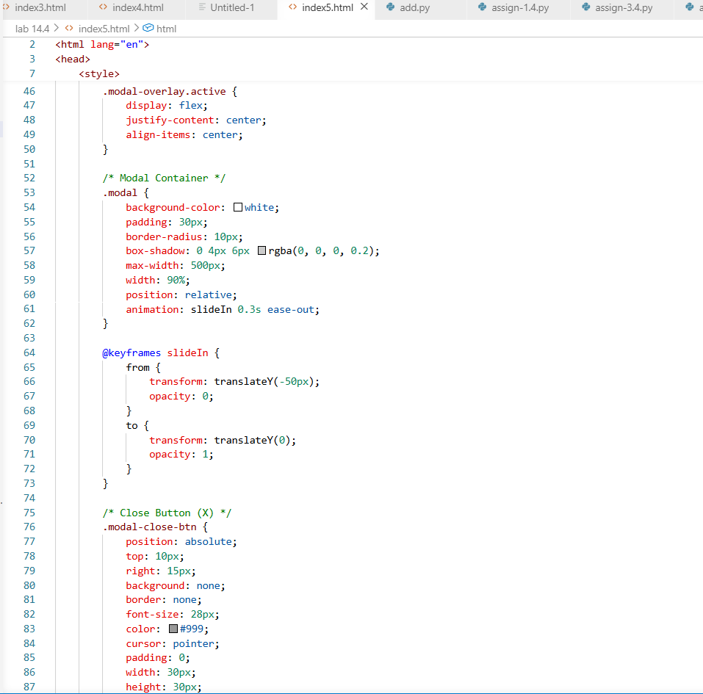
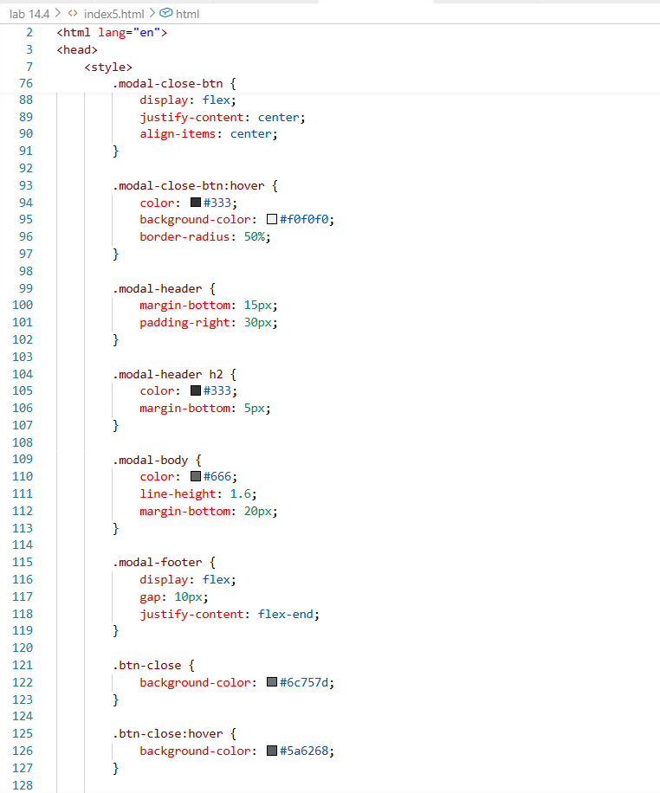
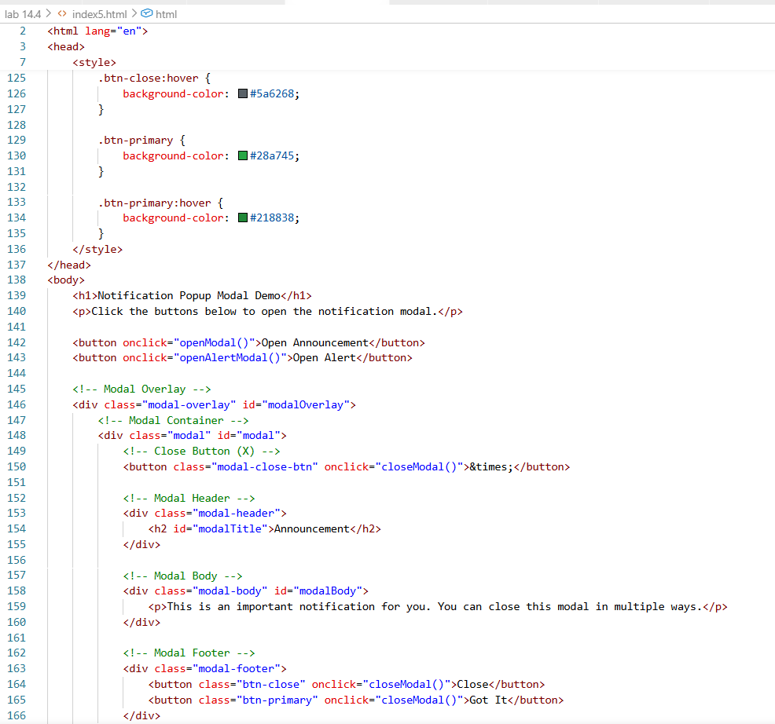
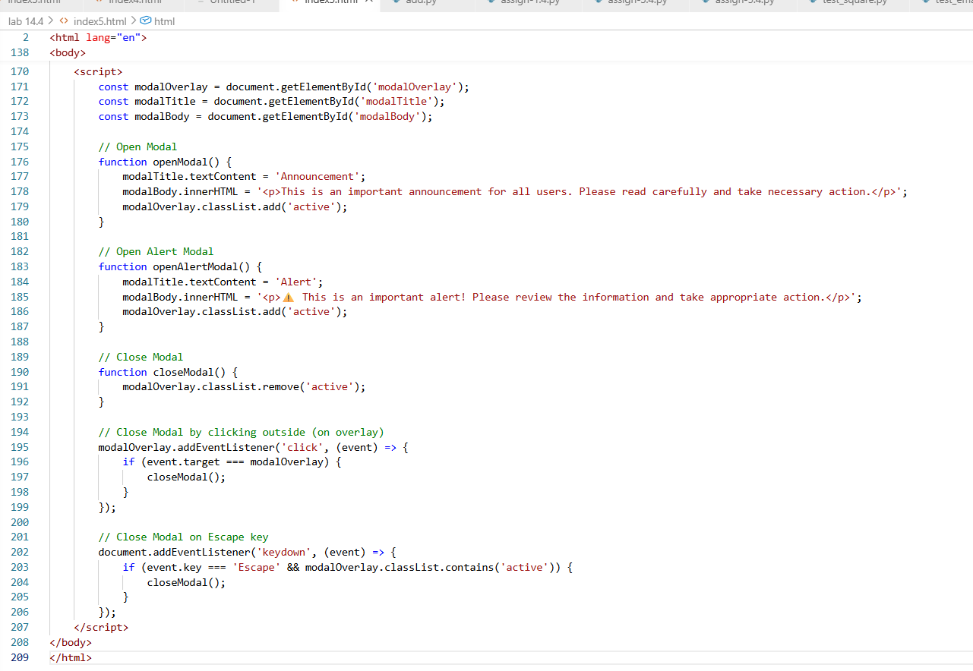

Output:-
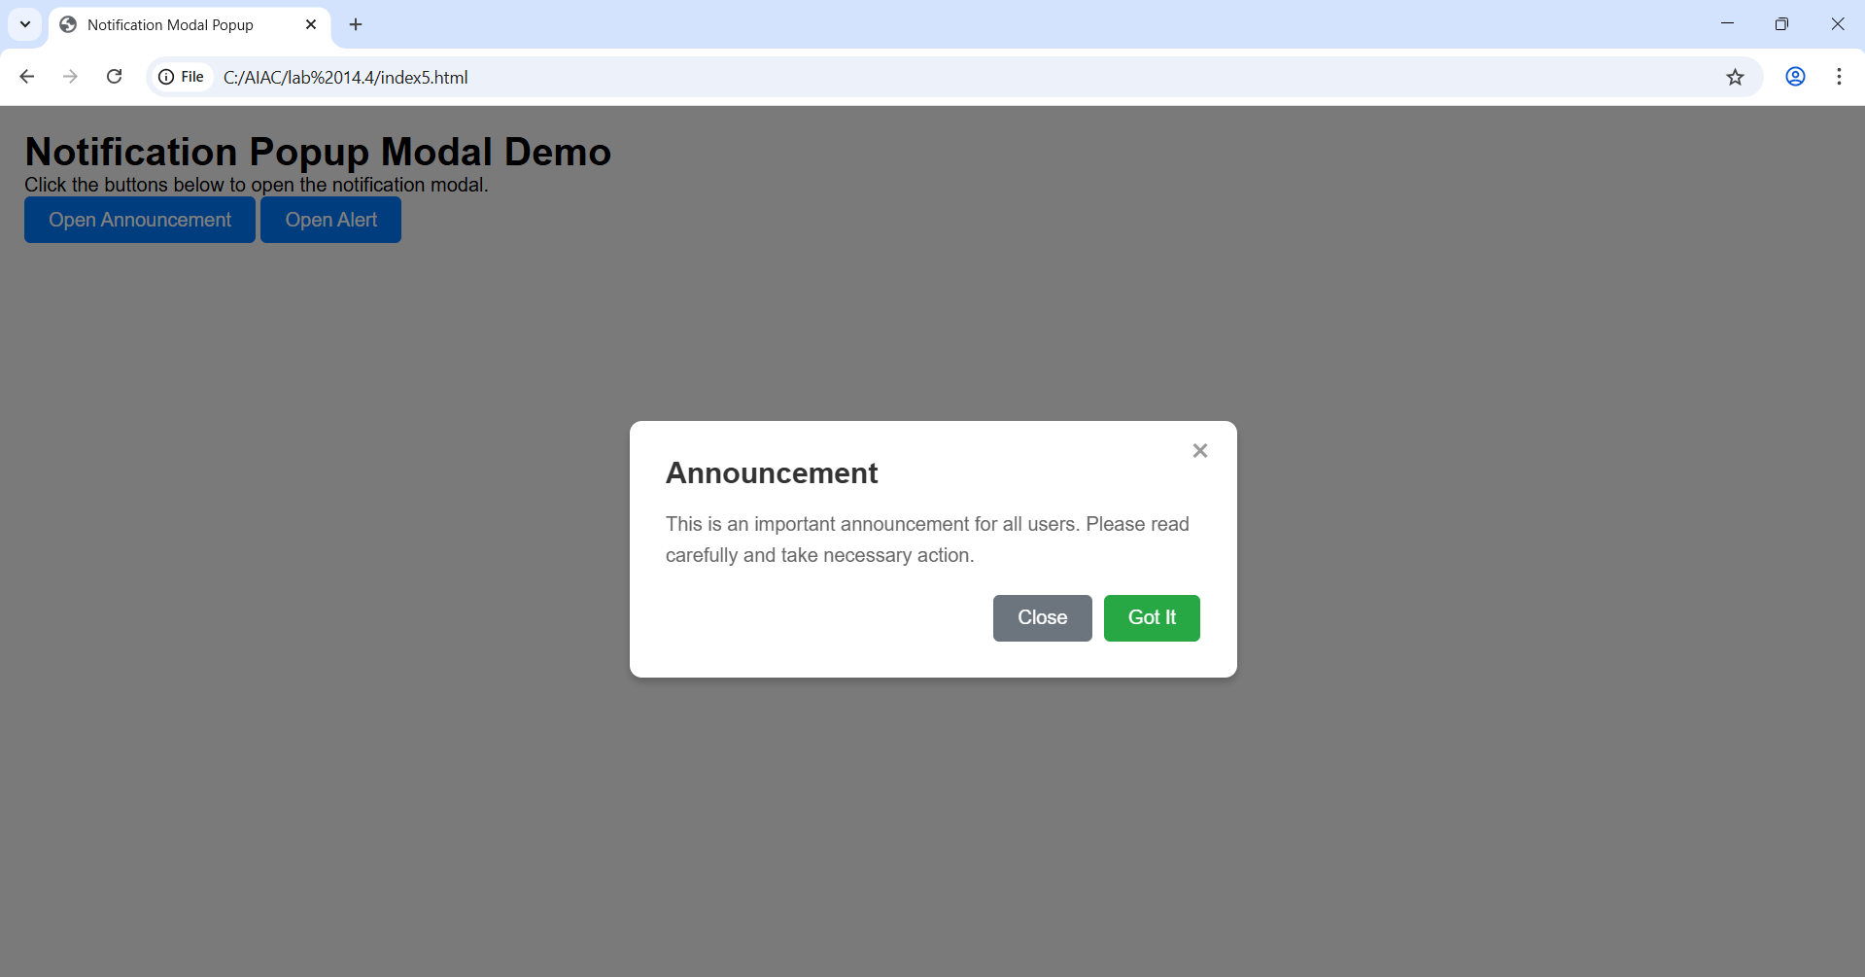
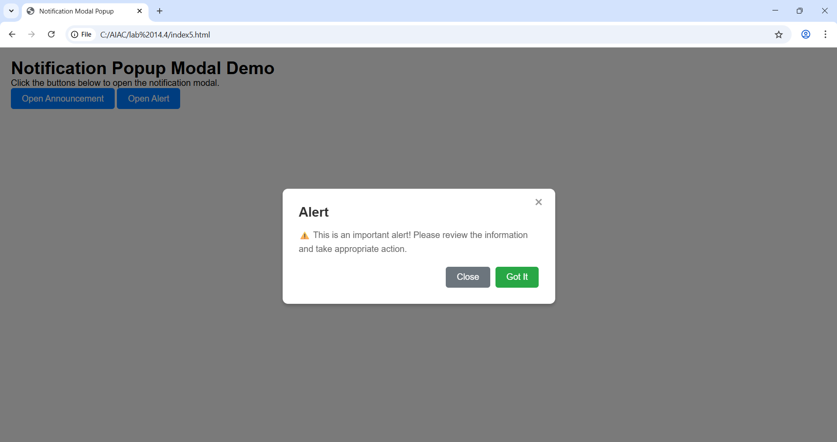
Explanation:-
A modal popup is created using HTML, CSS, and JavaScript to display notifications. Clicking the “Open Modal” button shows the popup with a background overlay. The modal can be closed using a close button or by clicking outside the popup.

Note: Report should be submitted a word document for all tasks in a single document with prompts, comments & code explanation, and output and if required, screenshots

